* Web Designing Assignment

Module: 1 HTML

1. Are the HTML tags and elements the same thing?

* Tags and Elements are not the same. They are the pieces themselves, i.e. a paragraph is an element, or a header is an element, even the body is an element.

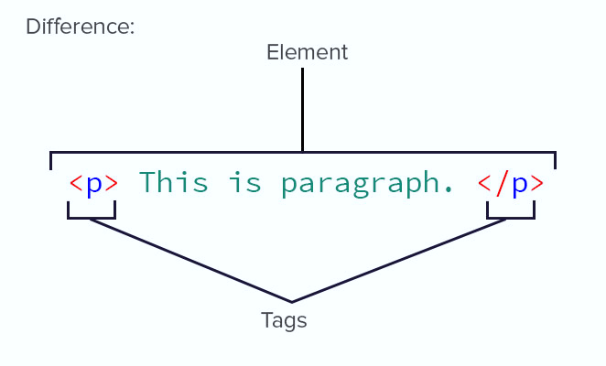

1. What are tags and attributes in HTML?

* *HTML tags are used to hold the HTML element.

*HTML element holds the content.

*HTML attributes are used to describe the characteristic of an HTML elements in detail.

HTML tags starts with < and ends with > Whatever written within a HTML tag are HTML elements.

1. What are void elements in HTML?

* A void element is an element whose content model never allows it to have contents under any circumstances. Void elements can have attributes. The following is a complete list of the void elements in HTML : area , base , br , col , command , embed , hr , img , input , keygen , link , meta , source etc.

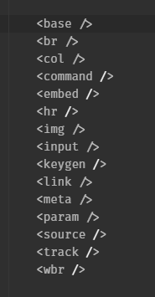

1. What are HTML Entities?

* An HTML entity is **a piece of text ("string") that begins with an ampersand ( & ) and ends with a semicolon ( ; )**. Entities are frequently used to display reserved characters (which would otherwise be interpreted as HTML code), and invisible characters (like non-breaking spaces)

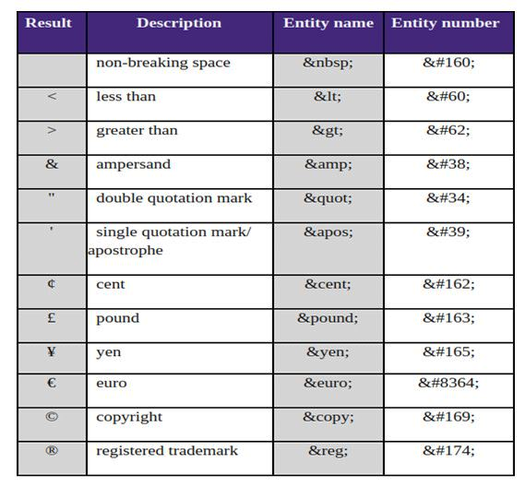

1. What are different types of lists in HTML? What is the class attribute in HTML?

* There are three list types in HTML:

1. Unordered list — used to group a set of related items in no particular order.
2. Ordered list — used to group a set of related items in a specific order.
3. Description list — used to display name/value pairs such as terms and definitions.

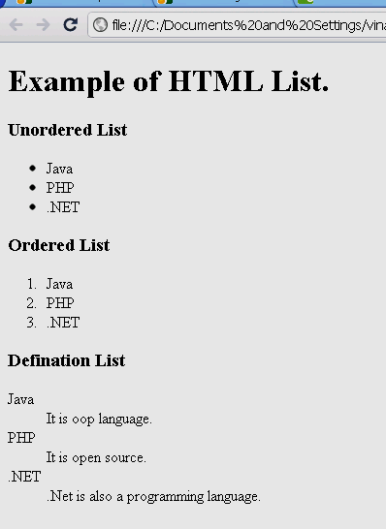

* The class attribute **specifies one or more classnames for an element**. The class attribute is mostly used to point to a class in a style sheet. However, it can also be used by a JavaScript (via the HTML DOM) to make changes to HTML elements with a specified class.

Example

<html>  
<head>  
<style>  
h1.intro

{  
    color: blue;  
}  
  
p.important

{  
    color: green;  
}  
</style>  
</head>  
<body>  
  
<h1 class="intro">Header 1</h1>  
<p>A paragraph.</p>  
<p class="important">Note that this is an important paragraph. :)</p>  
  
</body>  
</html

1. What is the difference between ‘id’ attribute and the ‘class’ attribute in HTML?

* Difference between id and class attribute: The only difference between them is that “id” is unique in a page and can only apply to at most one element, while “class” selector can apply to multiple elements.

Example

Id.html

! DOCTYPE html>

< html>

< head>

< title>

Id demo

< /title>

< style>

   #idDemo{

      color:green;

      font-size:25px;

   }

</style>

</head>

<body style="text-align:center">

<h1>Get element by Id</h1>

<p id="idDemo">Demo for Id selector</p>

</body>

</html>

Class.html

<! DOCTYPE html>

<html>

<head>

<title>

Class demo

</title>

<style>

   .class Demo{

    Color: orange;

      font-size: 25px;

   }

</style>

</head>

<body style="text-align:center">

<h1>Get element by class</h1>

<p class="classDemo">Demo for class selector</p>

</body>

</html>

1. What are the various formatting tags in HTML?

* HTML facilitates the ability for formatting text just like we do in MS Word or any text editing software:
* <b> - Bold text
* <strong> - Important text
* <i> - Italic text
* <em> - Emphasized text
* <mark> - Marked text
* <small> - Smaller text
* <del> - Deleted text
* <ins> - Inserted text
* <sub> - Subscript text
* <sup> - Superscript text.

1. How is Cell Padding different from Cell Spacing?

* Cell padding: Cell padding basically defines the space present between a table cell's border and the content present in it.

Cell Spacing: Cell spacing basically defines the space present between individual adjacent cells.

**Example:**

|  |
| --- |
| <!DOCTYPE html>  <html lang="en">  <head>      <meta charset="UTF-8">      <meta name="viewport"            content="width=device-width,                     initial-scale=1.0">      <title>Document</title>      <style>          span{            text-decoration-style: solid;            width: 25px;            font-size: x-large;            color: blueviolet;          }        </style>  </head>  <body>  <table border="1"         cellpadding="4"         cellspacing="5">    <thead>    <td><span>Name</span></td>    <td><span>Age</span></td>    </thead>    <tbody>    <tr>      <td>Rani</td>      <td>30</td>    </tr>     <tr>      <td>Rajan</td>      <td>35</td>    </tr>    <tr>      <td>Akshaya</td>      <td>17</td>    </tr>    <tr>      <td>Ashish</td>      <td>13</td>    </tr>    </tbody>  </table>  </body>  </html> |

**Output:**  
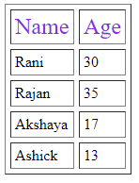

**Difference between cellpadding and cellspacing:**

|  |  |
| --- | --- |
| **Cellpadding** | **Cellspacing** |
| It specifies the space between the border of a table cell and its contents. | It specifies the space between adjacent cells. |
| It is created by using HTML <table> tag but type attribute is set to cellpadding. | It is also created by using HTML <table> tag but type attribute is set to cellspacing. |
| It is mainly meant for a single cell. | Cellspacing can get subjected to more than one cell. |
| The default cellpadding value is 1 | Whereas, the default cellspacing value is 2 |
| Cellpadding is widely used and considered to be an effective mean | Cellspacing is less effective than Cellpadding. |
| Cellpadding is an attribute | Cellspacing is also an attribute. |

1. How can we club two or more rows or columns into a single row or column in an HTML table?

* It can be done by using the rowspan and colspan attribute in HTML.

The rowspan is used to merge or combine the number of cells in a row whereas the colspan is used to merge column cells in a table.

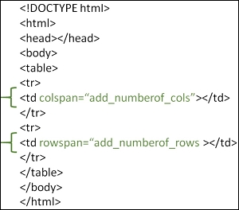

1. What is the difference between a block-level element and an inline element?

* By default, inline elements do not force a new line to begin in the document flow.

Block elements, on the other hand, typically cause a line break to occur (although, as usual, this can be changed using CSS).

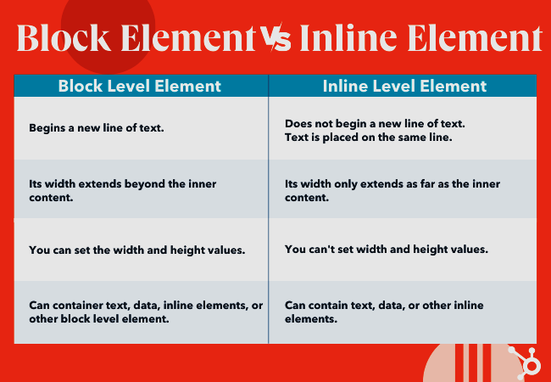

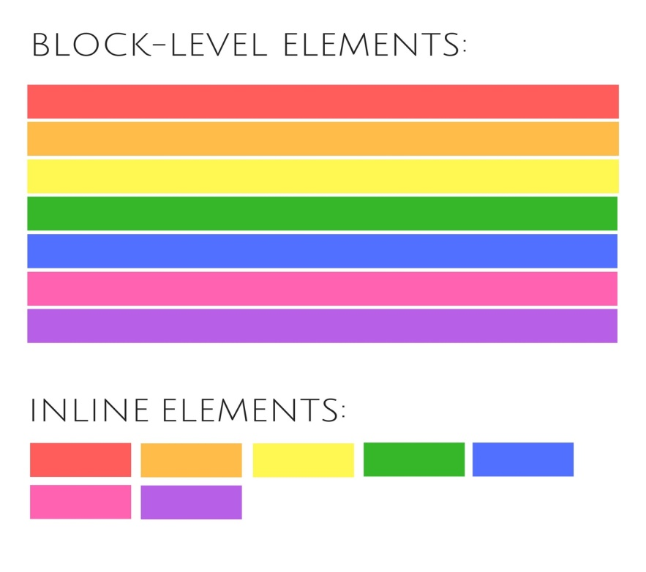

1. How to create a Hyperlink in HTML?

* A hyperlink is defined between an <a> tag and a closing </a> tag. The text between these two tags takes a user to the linked web resource when the link is clicked. The text between our tags will link to the URL that we specify in our opening tag.

<a href=https:/www.google.co.in/>google</a>

1. What is the use of an iframe tag?

* The <iframe> tag specifies an inline frame. An inline frame is used to embed another document within the current HTML document.

<iframe src="https://www.google.com" title="Practicals"></iframe>

1. What is the use of a span tag? Explain with example?

* The span tag is used for the grouping of inline elements & this tag does not make any visual change by itself. Span is very similar to the div tag, but div is a block-level tag and span is an inline tag.

Example 1: In this example, we simply use span tag with style in HTML.

<p> Bijal <span style="color:blue"> Joshi </span> morning.</p>

14. What is the use of a span tag? Explain with example?

* The <span> tag is an inline container used to mark up a part of a text, or a part of a document. The <span> tag is easily styled by CSS or manipulated with JavaScript using the class or id attribute. The <span> tag is much like the <div> element, but <div> is a block-level element and <span> is an inline element.

<p>Hello <span style="color:blue"> Good </span> morning.</p>

15. How to insert a picture into background image of a web?

* To set the background image of a webpage, use the CSS style. Under the CSS <style> tag, add the property background-image. The property sets a graphic such as jpg, png, svg, gif, etc. HTML5 do not support the <body> background attribute, so CSS is used to change set background image.

1. How are active links different from normal links?

* Normal links are links which are there on the page and have not been clicked yet. Active links are those links, which have just been clicked at that instant.

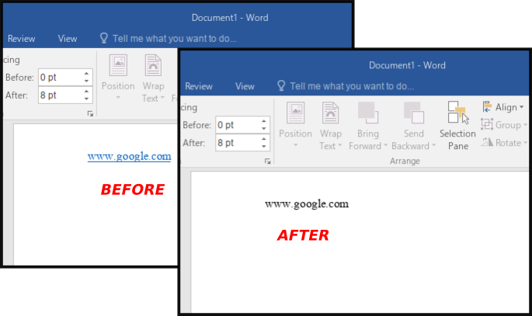

1. What are the different tags to separate sections of text?

* The <br> tag is one way to separate the lines of text. There are other tags like the <p> tag and <blockquote> tag that are also used to separate sections of text.

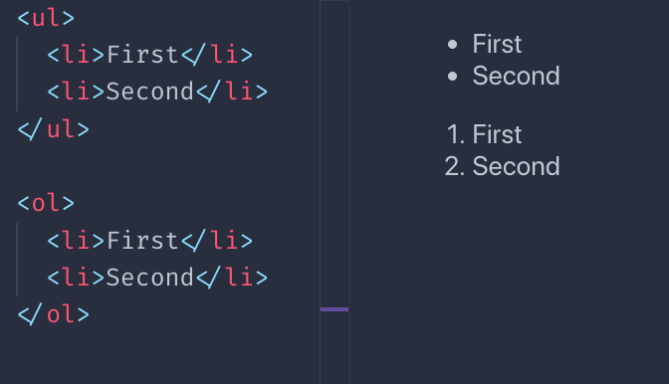

1. What is SVG?

* Scalable Vector Graphics (SVG) is an XML-based vector image format for defining two-dimensional graphics, having support for interactivity and animation. The SVG specification is an open standard developed by the World Wide Web Consortium since 1999.

1. What is the difference between HTML and XHTML?

* HTML stands for Hypertext Markup Language, whereas XHTML stands for Extensible Hypertext Markup Language. XHTML is basically an extension to HTML which is stricter than HTML. Both the languages are used to create web and Android applications. HTML is SGML based, whereas XHTML is an XML based language.

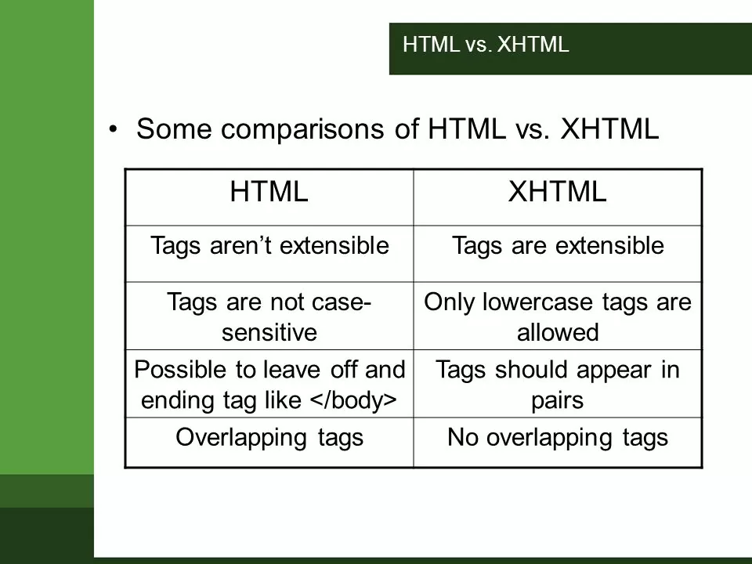

20. What are logical and physical tags in HTML?

* Physical and Logical tags are used in HTML for better visibility and understanding of the text by the user on the web page. However, both tags differ from each other as suggested by their names. Logical Tags: Logical Tags are used in HTML to display the text according to the logical styles.

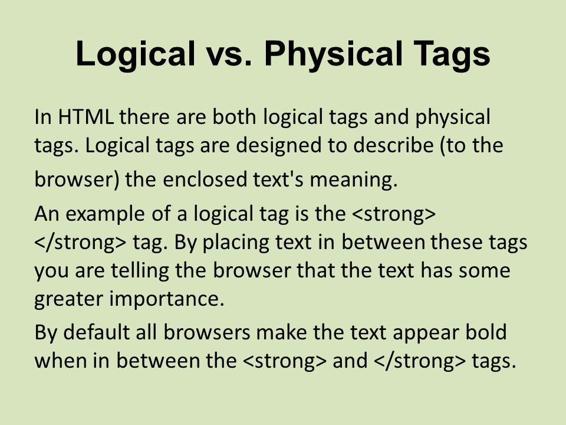

MODULE: 3 (HTML 5)

• What are the new tags added in HTML5?

* New tags of HTML 5:-
*  Article,
*  aside,
*  audio,
*  canvas,
*  command,
*  datalist,
*  details,
*  embed,
*  figcaption,
*  figure,
*  footer,
*  header,
*  hgroup,
*  keygen,
*  mark,
*  meter,
*  nav,
*  output,
*  progress,
*  rp, ruby,
*  section,
*  source,
*  summary,
*  time,
*  video

• How to embed audio and video in a webpage?

* To embed audio in HTML, we use the <audio> tag. Before HTML5, audio cannot be added to web pages in the Internet Explorer era.

The <vid eo> element allows us to embed video files into an HTML, very similar to the way images are embedded.

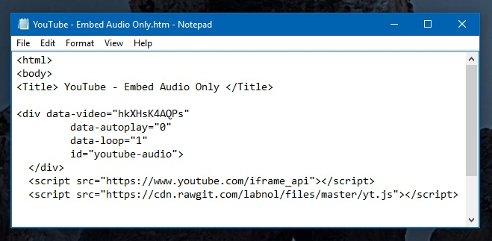

• Semantic element in HTML5?

* Semantic HTML elements are those that clearly describe their meaning in a human- and machine-readable way. Elements such as <header> , <footer> and <article> are all considered semantic because they accurately describe the purpose of the element and the type of content that is inside them.

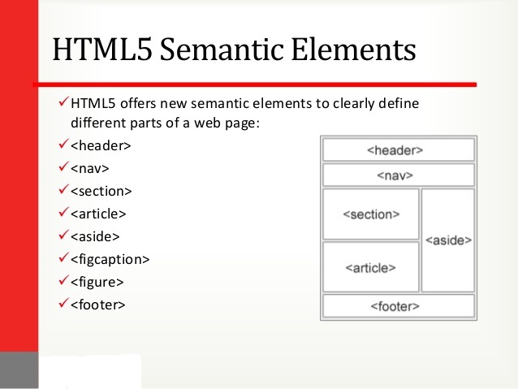

• Canvas and SVG tags

* SVG is a language for describing 2D graphics in XML. Canvas draws 2D graphics, on the fly (with a JavaScript). SVG is XML based, which means that every element is available within the SVG DOM. You can attach JavaScript event handlers for an element.

